**Partnerize**

*Site Genesis LINK Cartridge Integration guide*

*Version 21.1.1 – SG*



Table of Contents

1. Summary 3

2. Component Overview 4

Functional Overview 4

Limitations, Constraints 4

Contract 4

Compatibility 4

Privacy, Payment 4

3. Implementation Guide 5

Setup of Business Manager 5

Importing cartridges 5

Assigning cartridges to the site 7

Import of metadata 8

Configuration 9

Custom Site Preferences 9

Enable Partnerize BM extension 11

Service 13

Custom Code 13

Perform changes in controllers 13

Perform changes in templates 14

Business Manager 16

Create Partnerize Tag 16

Firewall Requirements 17

4. Testing 17

5. Operations, Maintenance 17

Data Storage 17

Availability 17

Failover/Recovery Process 17

Support 17

6. Known Issues 17

7. Release History 17

# Summary

The Partnerize LINK cartridge allows you to quickly integrate a Parnterize instance into a Salesforce Commerce Cloud website. The Partnerize platform is an artificial intelligence-powered Partnerize Partner Automation system. The platform delivers the data-driven analytics and industry-leading management tools you need to dramatically improve your ROI on this fast-growing sales channel.

This LINK cartridge contains instructions that allow you to integrate with a reference Partnerize application.

**Glossary**

|  |  |
| --- | --- |
| Term | Description |
| SFCC | Salesforce Commerce Cloud |
| Business Manager (BM) | The primary tool used to configure the SFCC platform and customer storefront |
| SG | Site Genesis |

# Component Overview

## Functional Overview

Partnerize app implements a tracking pixel that is triggered when a customer has made a purchase in a store and sends all transaction data to Partnerize. Pixel tracking is the most common implementation of conversion tracking by advertisers and 3rd party tagging solutions. It matches conversions to clicks using cookies dropped by the Partnerize tracking servers at the point where the user clicks a Partnerize publisher click link. They are initially redirected to the Partnerize tracking API, then passed on to the relevant advertiser destination URL. When the user converts on the advertiser site, a pixel call is rendered on the Web page, which connects the user to the Partnerize tracking API, and attempts to find a matching click if a Partnerize cookie resides within their browser. If a match exists the sale is awarded to the relevant publisher, and all transactional data captured via the tracking pixel is recorded.

## Limitations, Constraints

### Contract

To work with the cartridge, you need to contact the Partnerize support service to send your personal account to gain access to the Partnerize services.

## Compatibility

The cartridge is designed for Salesforce Commerce Cloud API version 21.3 (Compatibility Mode: 19.10) with

SG version 105.1.0. The cartridge is designed with US locale but multi-locale and multi-currency support.

## Privacy, Payment

The Partnerize cartridge does not collect and process user profile information or billing information. For additional privacy information, please contact your Partnerize Account Manager.

# Implementation Guide

## Setup of Business Manager

### Importing cartridges

1. Download the cartridge source code.
2. Establish a new digital server connection with your SFCC Instance
3. Import cartridges to a workspace in Salesforce UX Studio.  
   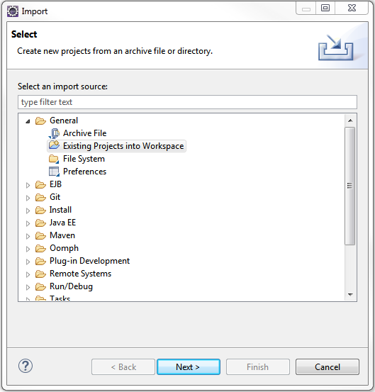
4. Add cartridges to Project Reference of Server Connection.  
   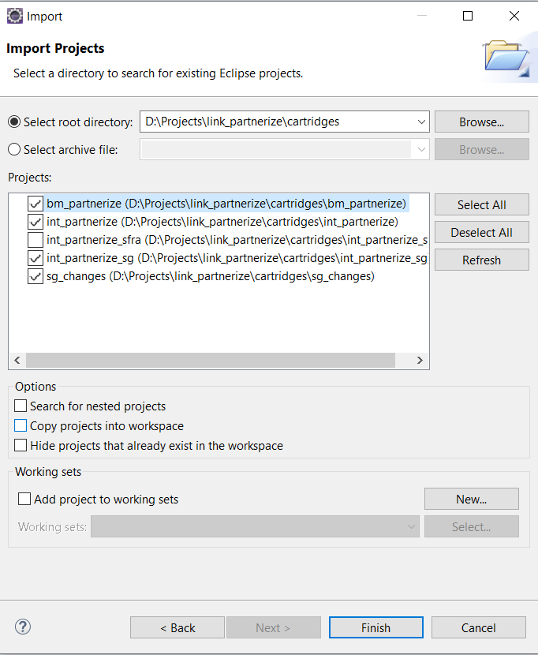
5. Wait until Studio completes workspace build and uploads source codes to the sandbox.

### Assigning cartridges to the site

Go to Administration > Sites > Manage Sites > Select your site from the list “Storefront Sites”.  
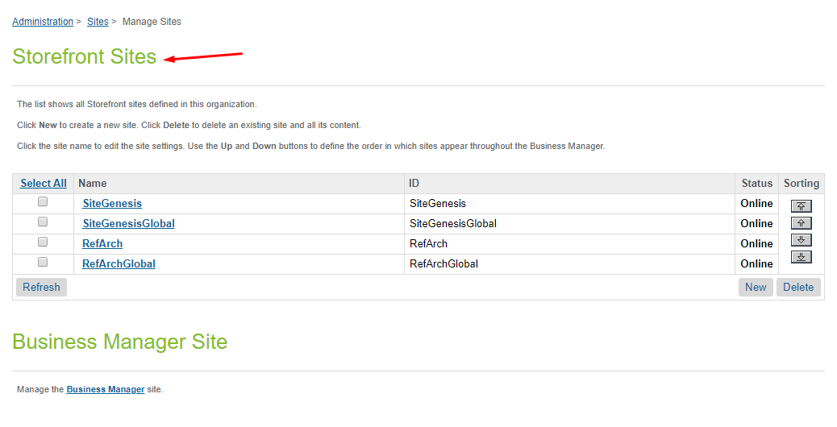  
  
Select Settings tab. In the beginning of the cartridge path add the following:  
sg_changes:int_partnerize:int_partnerize_sg

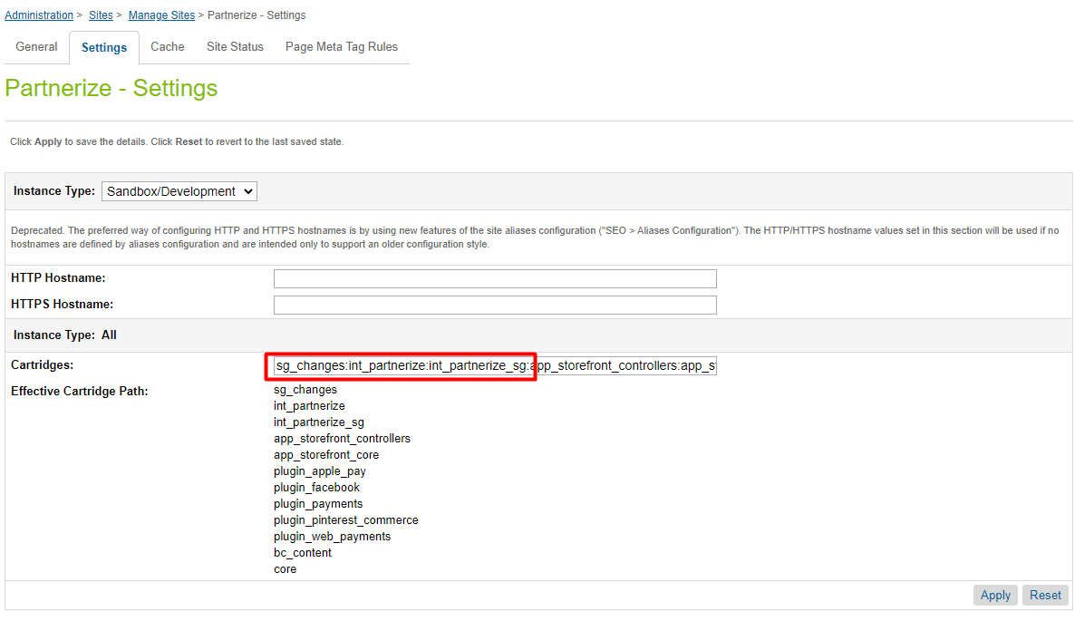

*Assigning cartridges to the business manager*  
Go to Administration > Sites > Manage Sites > Select “Manage the Business Manager site.”.

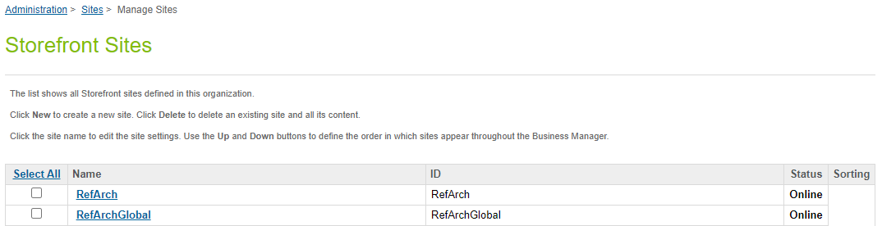

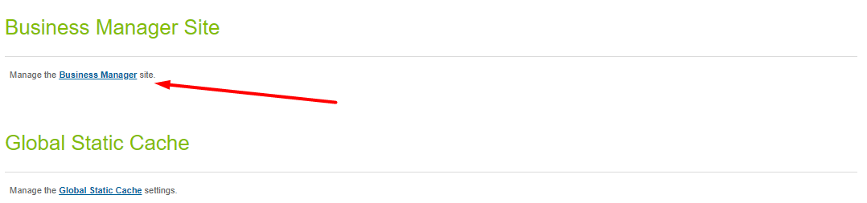

Select Settings tab. In the beginning of the cartridge path add the following:  
bm_partnerize:int_partnerize.

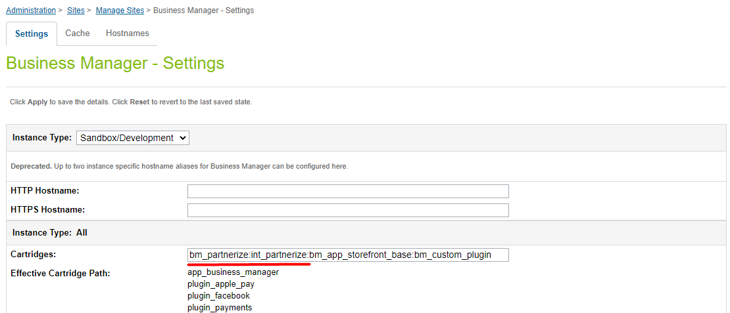

Click Apply button

### Import of metadata

Go to Administration > Site Development > Site Import & Export. Upload *partnerize.zip* from *metadata* folder.

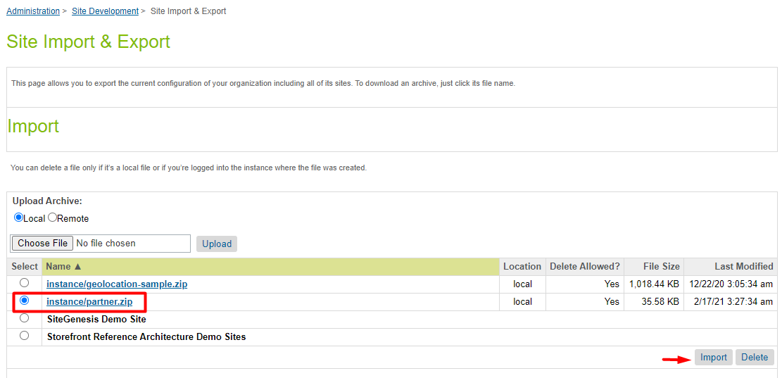

Select partnerize.zip and finish the import process.

## Configuration

### Custom Site Preferences

After import is successfully done, you should see Site Preferences in BM > Merchant Tools > Site Preferences > Custom Preferences.

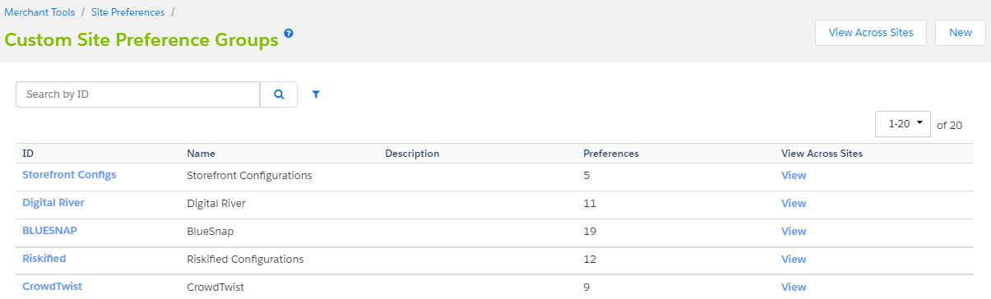

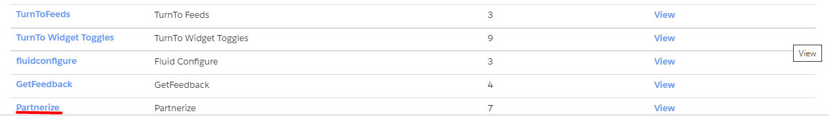

Select Partnerize and you should see fields for cartridge setup.

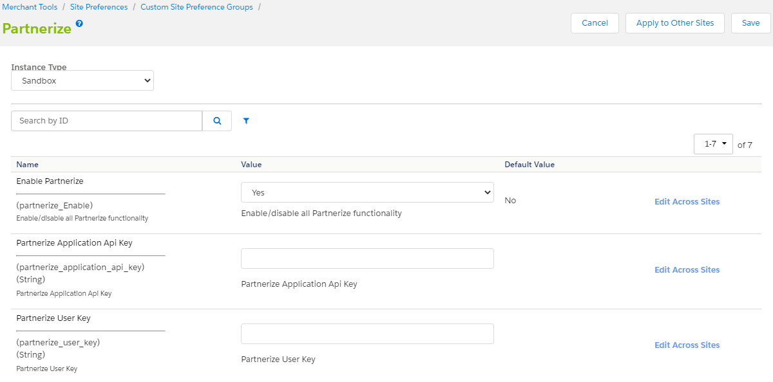

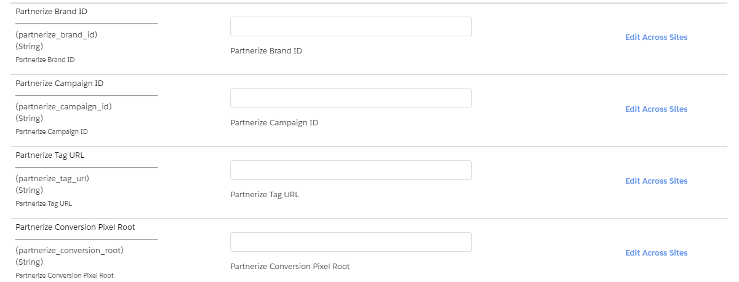

|  |  |  |
| --- | --- | --- |
| # | Field Title | Description |
| 1 | Enable Partnerize | Enable/disable all Enable Partnerize functionality |
| 2 | Partnerize Application Api Key | Partnerize Application Api Key assigned by Partnerize Team. |
| 3 | Partnerize User Key | Partnerize User Key assigned by Partnerize Team. |
| 4 | Partnerize Brand ID | Partnerize Brand ID assigned by Partnerize Team. |
| 5 | Partnerize Campaign ID | Partnerize Campaign ID assigned by Partnerize Team. |
| 6 | Partnerize Tag URL | Partnerize Tag URL. The URL will be assigned using the Partnerize BM expansion after filling in all custom preferences. For more details see chapter “Create Partnerize Tag”. |
| 7 | Partnerize Conversion Pixel Root | Partnerize Conversion Pixel Root assigned by Partnerize Team. |

### Enable Partnerize BM extension

Go to Administration > Organization > Roles & Permissions. Select the user group that you want to allow access to Partnerize BM extension (Administrator for example).

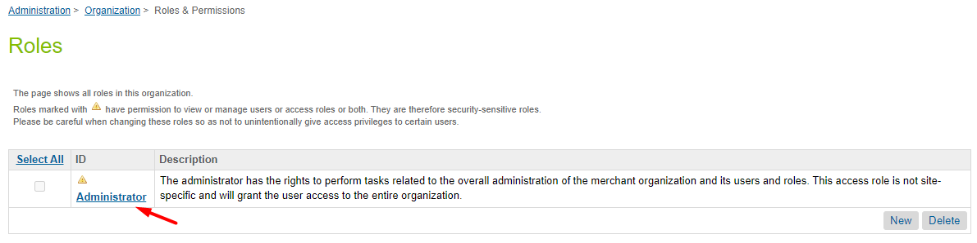

Select “Business Manager Modules” tab.

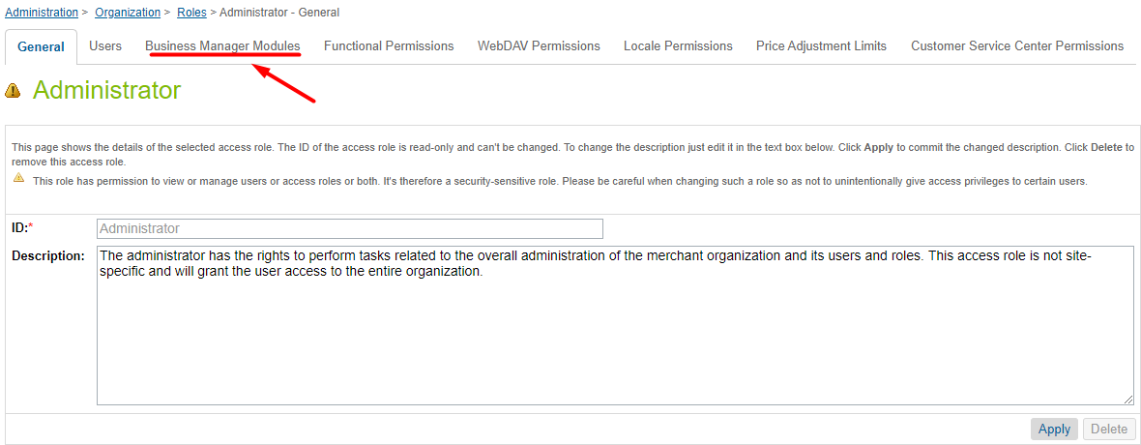

Select the site for which you want to allow the use of Partnerize BM extension.

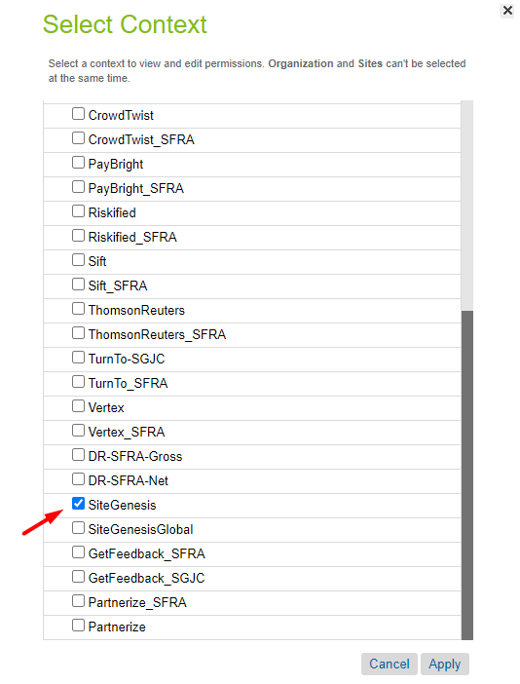

Set the checkbox for Create Partnerize Tag for Business Manager Module and click “Update” button

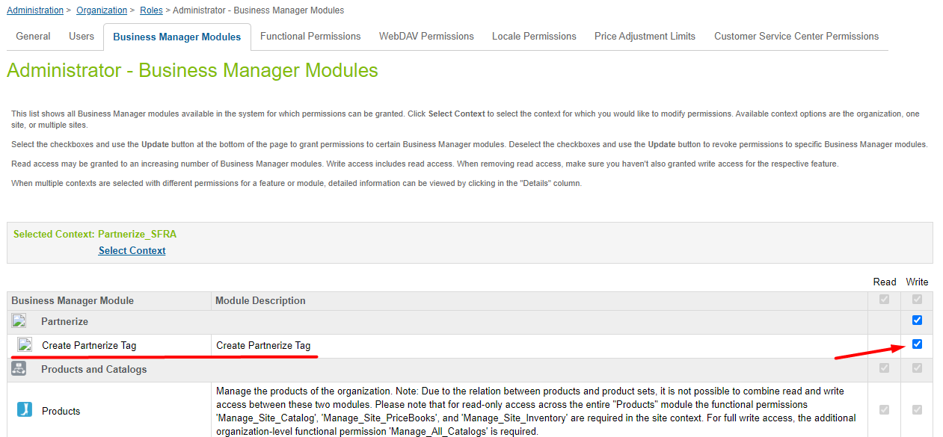

### Service

The service does not require additional settings.

## Custom Code

**Note: all changes are already made in the sg_changes cartridge.**

### Perform changes in controllers

1. YOUR_CARTRIDGE_controllers/cartridge/controllers/COSummary.js

Put the following rows in line 71 to the submit() function:

// --- Start Partnerize section ---

var order = placeOrderResult.Order;

if (order) {

Transaction.wrap(function () {

order.custom.partnerize_synced = false;

});

}

// --- End Partnerize section ---

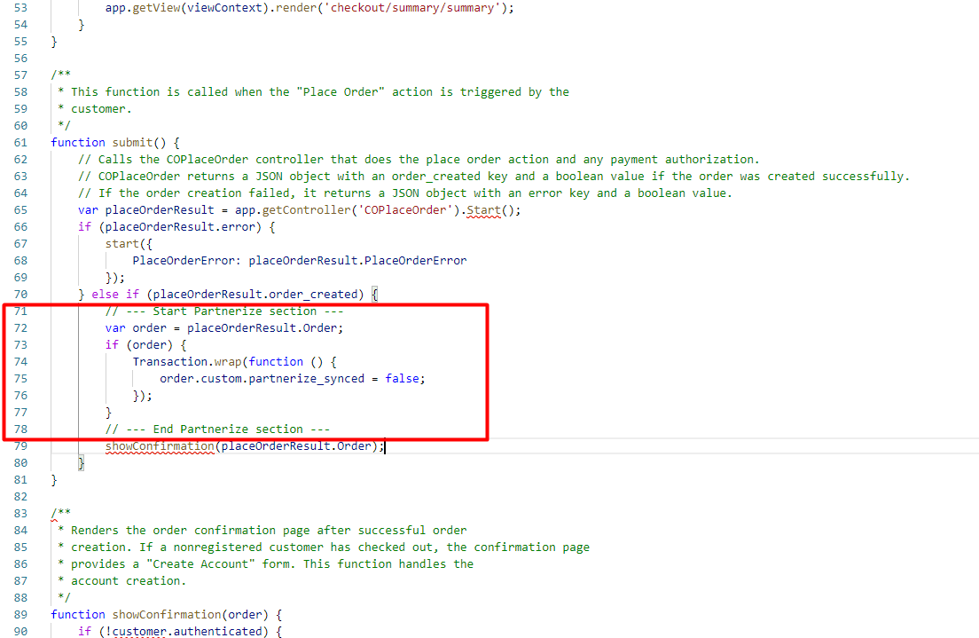

### Perform changes in templates

1. YOUR_CARTRIDGE_core/cartridge/templates/default/components/footer/pageFooter.isml

Put the following rows in line 24 to the and of <footer> section:

<iscomment> Partnerize script </iscomment>

<isif condition="${require('*/cartridge/scripts/lib/partnerizeData').getPreference('Enable')}">

<script type="text/javascript" src="${require('*/cartridge/scripts/lib/partnerizeData').getPreference('tag_url')}" async></script>

</isif>

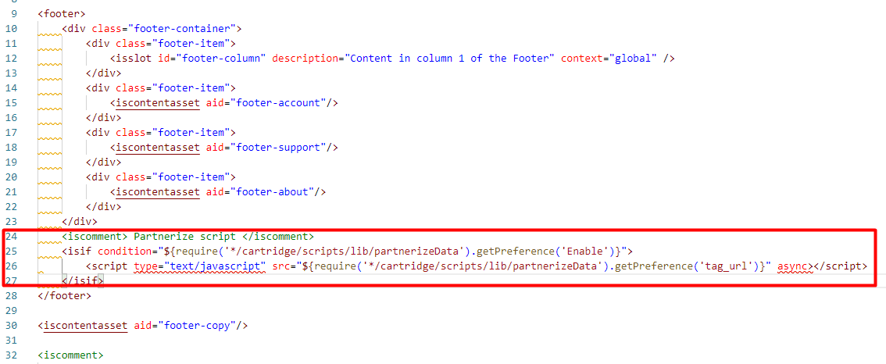

1. YOUR_CARTRIDGE_core/cartridge/templates/default/checkout/confirmation/confirmation.isml

Put the following rows in line 15:

<iscomment> Partnerize section (start) </iscomment>

<isif condition="${require('*/cartridge/scripts/lib/partnerizeData').getPreference('Enable')}">

<isinclude url="${URLUtils.url('Partnerize-ConversionTag','order_id', pdict.order.orderNumber)}">

</isif>

<iscomment> Partnerize section (end) </iscomment>

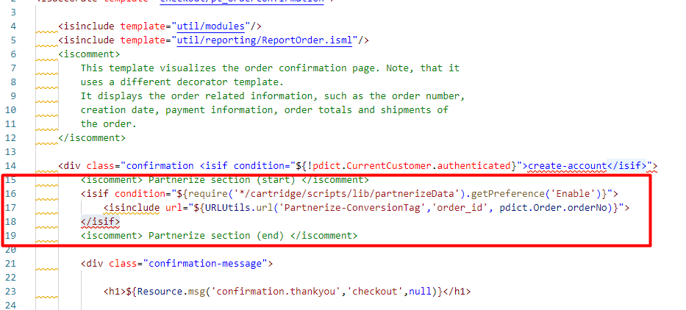

## Business Manager

### Create Partnerize Tag

Go to Administration > Partnerize > Create Partnerize Tag

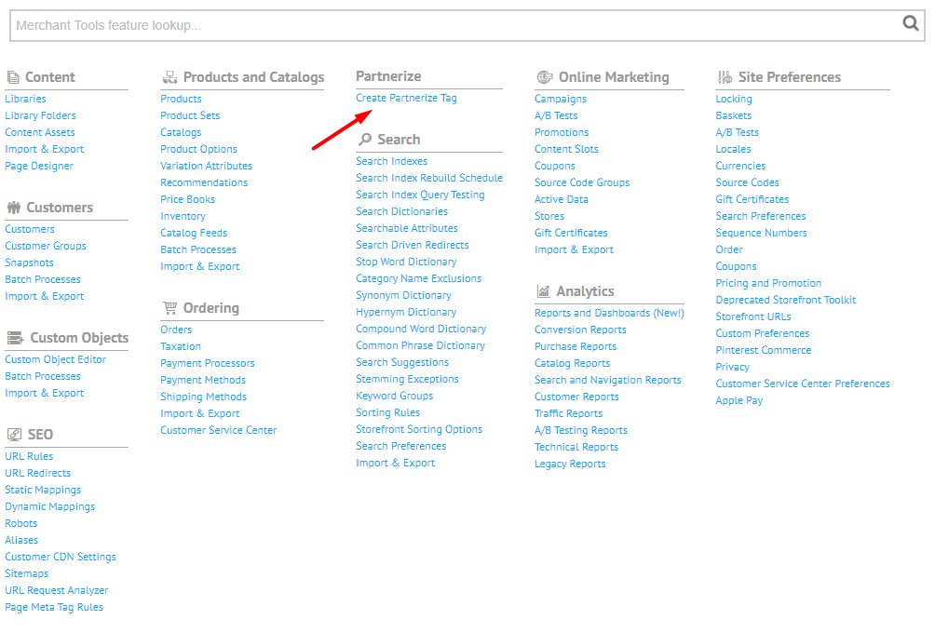

Click to the “Request and Apply Partnerize tag” button to get and activate the Partnerize tag from the Partnerize service.

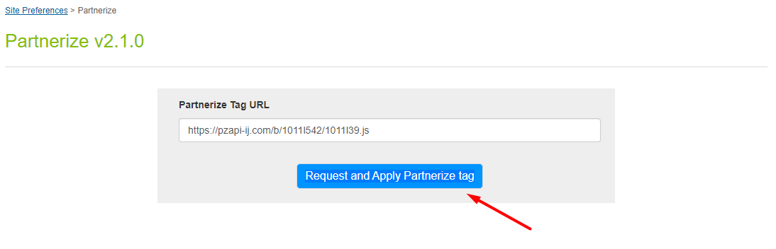

If the tag is received successfully, the message “Partnerize tag successfully created” will be displayed and it will be saved in custom preference. If a request fails, an error will be displayed. The error message will be written to the log file.

**You only need to create and apply the Partnerize tag once after installing the cartridge.**

The site name is used as a tag name when creating a Partnerize tag. If a tag with the same name already exists on the Partnerize service, it will not be created again and an error message will be displayed. To remove the tag, you should contact the support service of the partner.

## Firewall Requirements

No special firewall requirements

# Testing

Test cases for checking cartridge performance are described in the “Partnerize test cases” document.

# Operations, Maintenance

## Data Storage

Intentionally left blank

## Availability

If the Partnerize service becomes unavailable, the storefront continues to work without the service. All errors work of the service are saved in the log file.

## Failover/Recovery Process

Intentionally left blank

## Support

For questions please contact your Partnerize Success Manager.

# Known Issues

# Release History

|  |  |  |
| --- | --- | --- |
| **Version** | **Date** | **Changes** |
| 21.1.0 | 2021-02-01 | Initial release |
| 21.1.1 | 2021-08-07 | Metadata updated |
|  |  |  |
|  |  |  |
|  |  |  |